Skittles and Volume

- GOAL: Students will learn to determine the optimum volume and percent error
- OBJECTIVE:
  - Students will determine the measurements of a cylindrical object
  - Students will calculate the volume of a cylindrical object
  - Students will analyze and evaluate the volumes calculated
- MATERIALS:

Cylinder object: Cup | - Formulas  - Calculator  - Ruler  - Pencil/Pen  - SKITTLES!
REVIEW:
Definition of VOLUME: __________________________________________________________________________
Definition of a DIAMETER:
_____________________________________________________________________________________________________
_____________________________________________________________________________________________________
Definition of a RADIUS: __________________________________________________________________________
____________________________________________________________________________________________________

Useful Equations

Volume of a cylinder: V= 𝝅r²h
Estimation of Volume: (Space between the skittles)
= Amount of Skittles x Volume of one skittle
Percent Error = $\frac{Actual-Estimated}{Actual}$

PROCEDURE:
- FIND THE DIMENSIONS OF YOUR MUG
- PLUG DIMENSIONS INTO THE FORMULA FO THE VOLUME OF A CYLINDER
- FIND THE VOLUME AND LABEL APPROPRIATELY
- FILL THE CYLINDER(MUG) WITH SKITTLES
- COUNT THE SKITTLES AND RECORD YOUR FINAL ANSWER
  - WE WILL BE SHARING ANSWERS WITH CLASS
- THINK ABOUT THE RELATIONSHIP BETWEEN THE VOLUME AND NUMBER OF SKITTLES

Practice Question:
A soup can have a diameter of 10 cm and a height of 15 cm. What is the volume of the soup in the can if 0.5 cm of space is left at the top of the can?
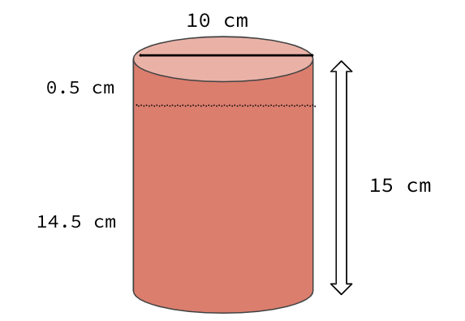
Diameter= 10cm

Radius= 5cm

Height= 15cm

V= 𝝅r²h
V= 𝝅(5)²(14.5)
V=1138.8cm³

What is the height and radius of your cup?
Height=12.5cm
Diameter=8.5cm
Radius=4.25cm

Find the volume using the calculations above:

V=709.3cm³

What is the estimated amount of space between each skittle? 20.15cm³

Now calculate the percent error:
Percent error= .9719= 97.19%

